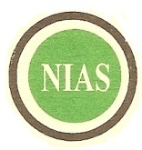
NIGERIAN INSTITUTE OF ANIMAL SCIENCE

RESCHEDULED 2025 GAS EXAMINATION UPDATE
NEW DATE FOR EXAMINATION
2025 GRADUATE ANIMAL SCIENTIST (GAS) | JUNE 27, 2026

EXAMINATION CENTRES | EXAMINATION DATE
North – Central Centre: ABUJA  North–East Centre: BAUCHI & MAIDUGURI  North – West Centre: KANO | JUNE 27, 2026
South – East Centre: UMUDIKE  South-South Centre: PORT HARCOURT | JUNE 27, 2026
South – West Centre: IBADAN, OGBOMOSO & ADO-EKITI

For further Enquiries call: 09077277781, 07070404667

